Experiment-6

# Aim: To write an assembly language program to add two 8-bit numbers

Tools Required: DOSBox v0.74-3 , TASM

Code ••

•

# Write/paste your first code here

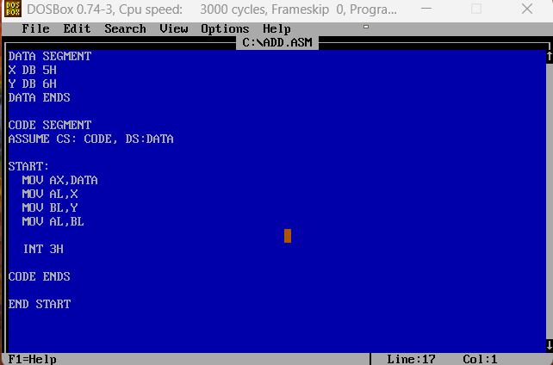

Output :

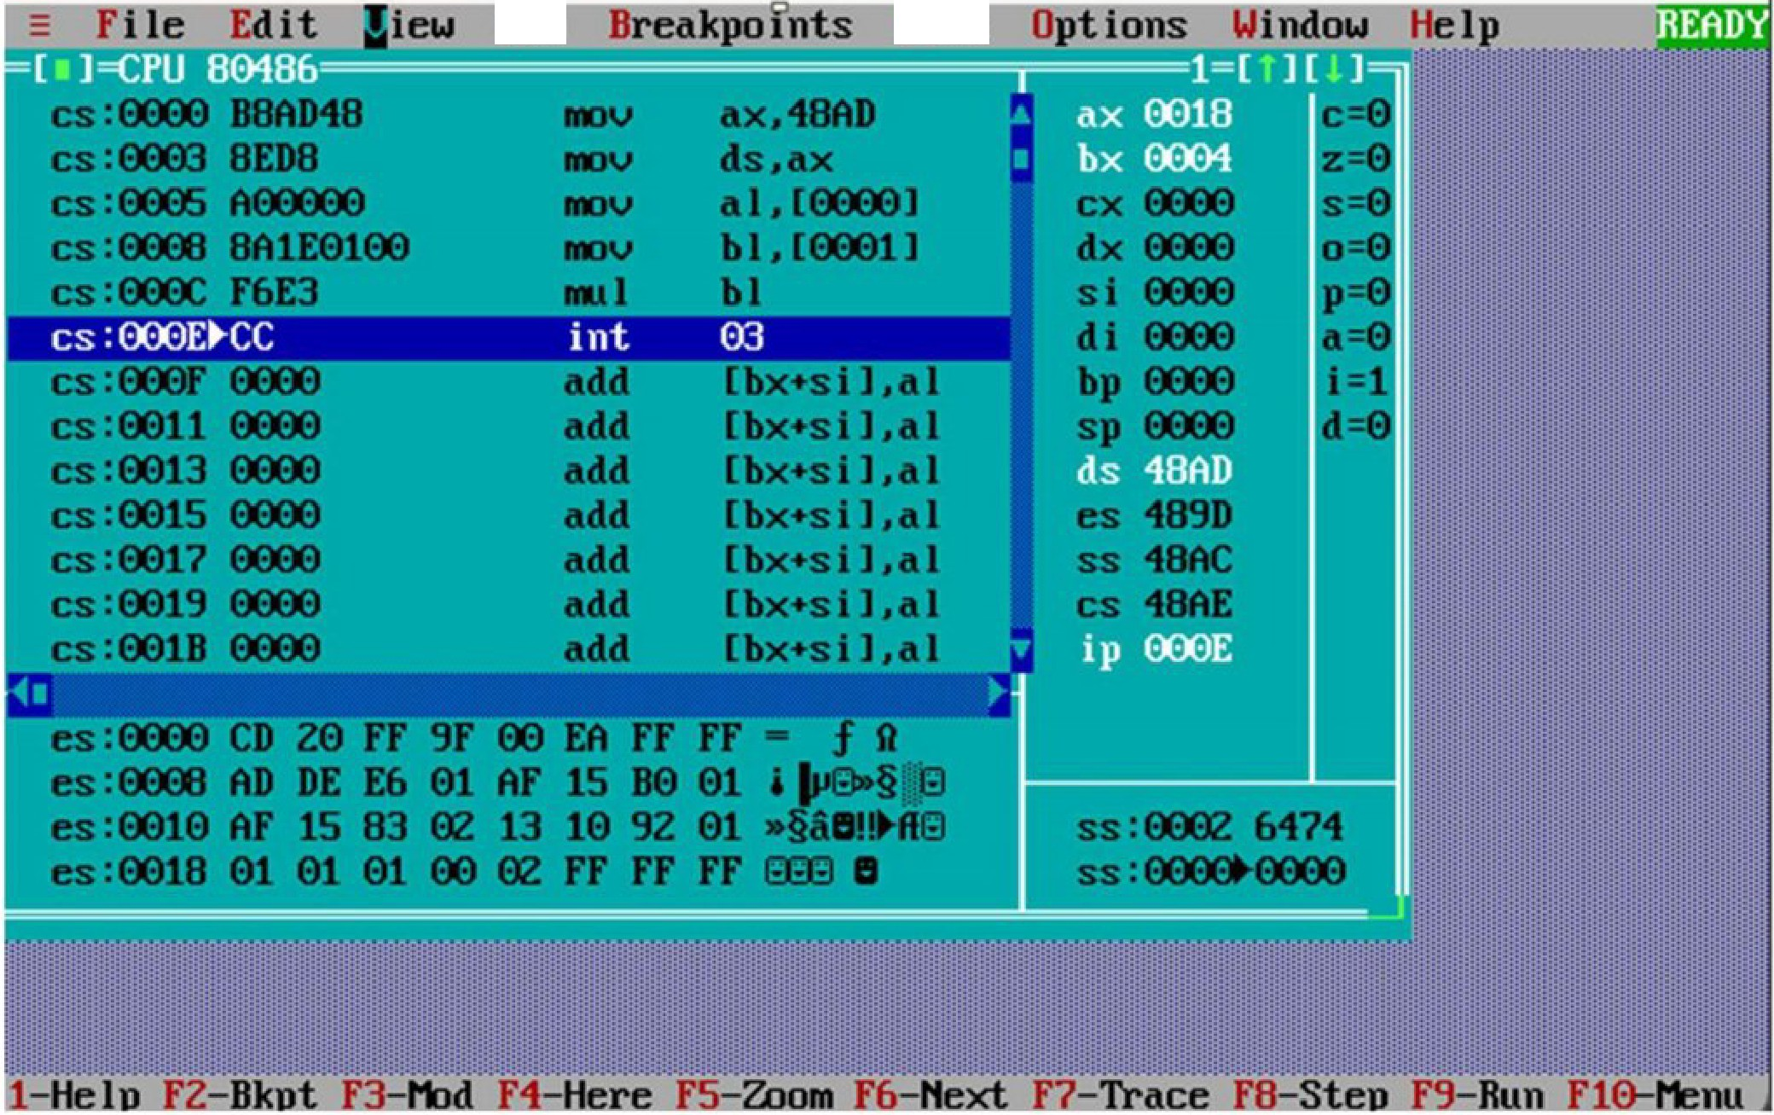

DOSBox 0.74-3, Cpu speed:

Rnn

3000 cycles, Fram •••

**Data**

X

**Code Interpretation: Paste the snapshot of your manual line by line interpretation of**

**the code as discussed in the class**

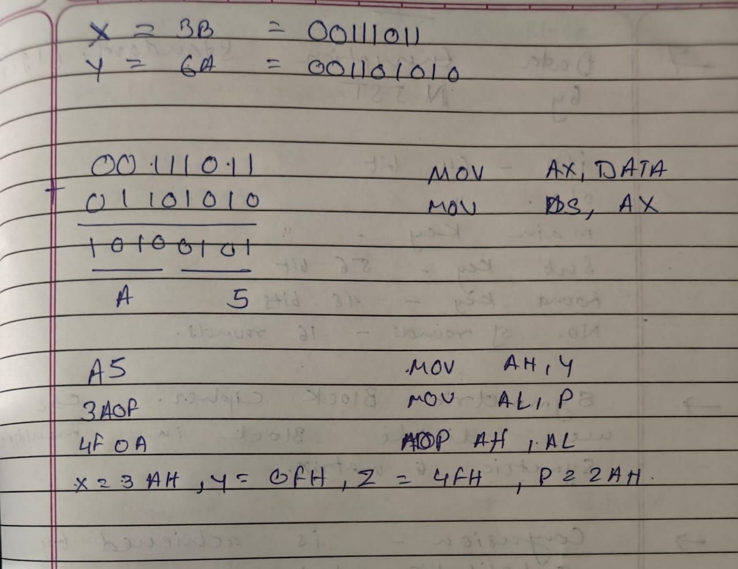

## Results:

## The sum is stored in AL (or whatever register you use) register.

* The Sum of 25H and lAH is 3FH, stored in BL register.

## Conclusion:

## The flags are updated after the program's Execution

**Lab Quiz:**

**Q1. Write the difference between assembly language and machine language.**

**Q2. What is an emulator? What are the different emulators for 8086 programming?**

**Q3. What are the different assemblers available for 8086 programming?**

**Q4. Write an assembly language program to add two 16-bit numbers. (Write code only,no manual interpretation is needed).**

Answers:

**A1). Difference between Assembly Language and Machine Language:**

| **Feature** | **Assembly Language** | **Machine Language** |
| --- | --- | --- |
| Level | Low-level (closer to human language) | Lowest-level (binary code understood by CPU) |
| Readability | More readable using mnemonics (e.g., MOV, ADD) | Not human-readable (uses 0s and 1s) |
| Translation | Requires an assembler to convert to machine code | Directly executed by the CPU |
| Portability | Specific to processor architecture | Also specific to processor architecture |
| Debugging and Maintenance | Easier than machine language | Very difficult to debug and maintain |

**A2). What is an Emulator? What are the different emulators for 8086 programming?**

An **emulator** is a software or hardware that mimics the behavior of a computer system, allowing one system to behave like another. In the context of 8086 programming, an emulator simulates the 8086 microprocessor environment, allowing code execution and debugging without actual hardware.

**Popular Emulators for 8086:**

* **EMU8086**
* **8086 Microprocessor Emulator**
* **DosBox (with TASM/MASM)**
* **Turbo Debugger (TD)**

**A3). What are the different assemblers available for 8086 programming?**

Assemblers convert assembly language code into machine code. Popular 8086 assemblers include:

* **MASM (Microsoft Macro Assembler)**
* **TASM (Turbo Assembler by Borland)**
* **NASM (Netwide Assembler)**
* **EMU8086’s Built-in Assembler**
* **A86 (Shareware assembler for x86)**

A4). Write an assembly language program to add two 16-bit numbers.

MOV AX, 1234h ; Load first number into AX

ADD AX, 0ABCDh ; Add second number to AX

Result is now in AX